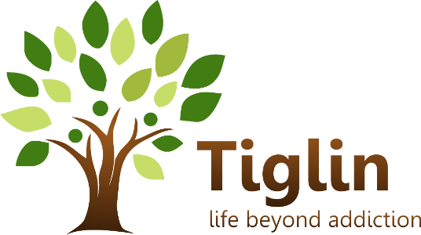 Date of referral: _________________

Programme referred to: | Please tick-x
Men’s Drug Free Residential-Ashford

Women’s Drug Free Residential-Brittas Bay

Arklow Day Services

Family Services

OTHER

Client Name | Address | Contact Number
Gender Male/ Female: | Ethnic Origin: | Family Status, Include dependent children
D.O.B: | Living with (circle one):  Alone, parents /family, friends, partner, partner & children, alone with children, foster care other, Not known | Living where (circle one):  stable accommodation, institution, homeless, unstable accommodation, other
P.P.S No: | Source of Referral (circle one): Self, Family, Friends, Other drug treatment centre GP ,Acute Hospital Service (excluding A&E), Social / Community Service, Court/Probation/Police, Outreach Worker Harm Reduction programme ,School,Prison,Employer ,Mental Health Liaison Nurse at A&E Accident & Emergency, other Mental health service (including psychiatrist) , Not known

Reason for Referral
Next of Kin

Name
Address
Phone
Is this person aware of drug use / contact with this service? Y N

Current Drug Use: (Please give details)
Type of contact with this programme circle one
First treatment One or more treatment periods Not known
Number of times started treatment in this programme this year (Jan to Dec) ……………..
Ever previously treated for problem drug use? Circle one
Never treated Previously treated Not known Not applicable
If previously treated, state which drug …………………….
If previously received opioid replacement treatment, please specify age first received opioid substitution treatment ……….. Not known
Specify first drug used (excluding alcohol) ………………age at first …………………….

Drug type
Please rate order of preference / regularity in the brackets e.g. 1, 2, 3 ect..
Age at first use How often How Often Amount used Route of transmission.
Heroin
( ___)
Cocaine
( ___)
Benzodiazepine
( ___)
Amphetamines
(Crystal Meth)
( ___)
Ecstasy
( ___)
Cannabis
( ___)
Alcohol
( ___)
Methadone
( ___)
Tobacco
( ___)
Codeine
( ___)
Other
( ___)
Current Alcohol Use: (Please give details)

Specify main type of alcohol consumed:
Beer ,spirits ,wine, fortified wine, cider, alcopops:
Other……………………………………………………………………..
How many drinks were consumed over a typical drinking session over the past month……………. If none, put 0
Number of days alcohol was consumed over the past month……………………………………………….. If none, put 0
Please categorise the extent of the drinking problem (as per audit tool circle one)
hazardous drinker harmful drinker dependent drinker
Ever previously treated for problem alcohol use? Circle one
Never treated Previously treated Not known Not applicable

Previous Detox & Rehabilitation Programmes: (Please give details)

Is a detox Needed? If so individual will need to be referred to detox centre

Why do you want treatment now?

Physical Health Needs (Please detail) | Mental Health Needs (Please detail) | Medication Prescribed | Dosage
GP/CLINIC | ADDRESS | TELEPHONE NUMBER

Legal Issues
Current Charges/orders. (Please Detail) | Next Court Date(s) | Probation Officer | Probation Involvement | Is urinalysis & court report requested
Current Offence(s) | Outstanding Charge(s) | Previous Convictions | Prison Release Date if applicable | Involvement in Feuds/Health & Safety concerns

Family Support/Concerned Persons/Significant Others: | Relationship to you | Phone Number

FAMILY SUPPORT REFERRAL DETAILS, (for family members-parents, spouses, partners, sibling or children of STUDENTS engaging with Tiglin Services).
PROGRAMME | PLEASE TICK | STUDENT NAME

FAMILY MEMBER NAME | PHONE: | RELATIONSHIP TO STUDENT: | ADDRESS: | PERMISSION TO CONTACT, PLEASE TICK

For Further Information please contact Marilyn at Tiglin Family Support 085)8875774

Referral Agent Name: | Keyworker/Probation Officer/Contact Person | Address | Telephone: | Length of contact with client
Services currently involved or which have been involved in service users care plan to date: -
_________________________________________________________________________________
What supports are needed for service user to progress
_________________________________________________________________________________
What are service users goals Short term/Long term
_________________________________________________________________________________
Staff will make contact with you within 4 days of receipt of this referral.
Referral Completed by: ____________________________ Date: ____________________
Thank you. Please return completed forms to: Tiglin Challenge, Ashford, Co. Wicklow or by email to admin@tiglin.ie; Fax Number: 0404)40020
Men’s Residential: 0404)49683; Women’s Residential 0404)47552; Tiglin Day Service: 0402)33898 & 085)8695964; Family Support 0858875774

